**Scitation and Shibboleth**

Authentication via Shibboleth happens at the article level. When a user tries to access full article content prior to being authenticated, they will be presented with options on how to access the full content.

**How a user authenticates**

From Scitation.org, Search for an article of interest and click the article.

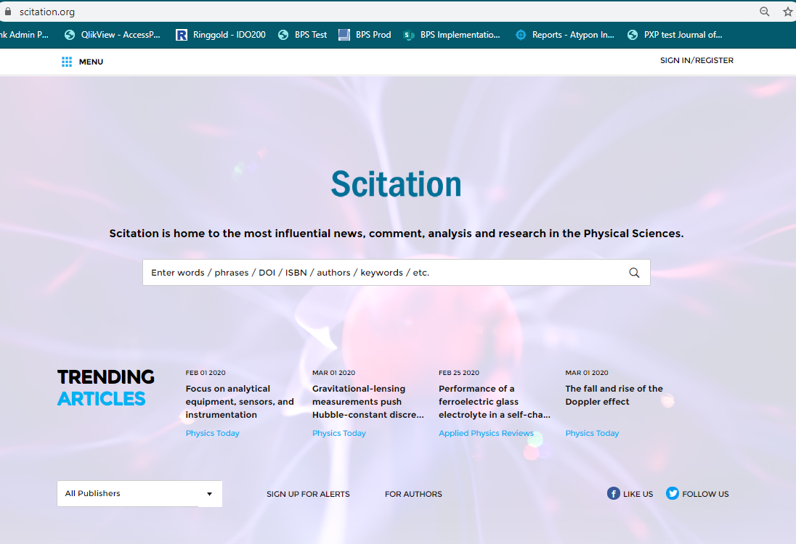

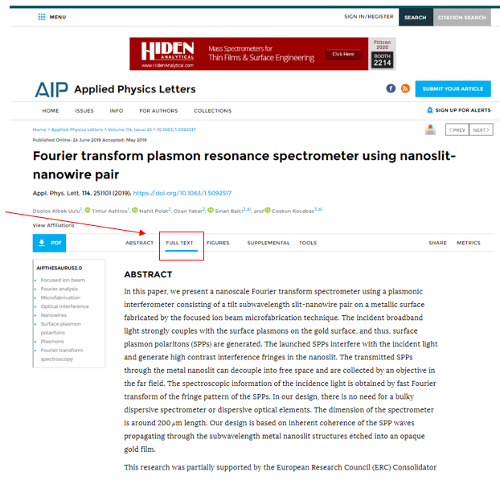

When on the full text tab, scroll down until you reach the paywall section and click the Shibboleth link

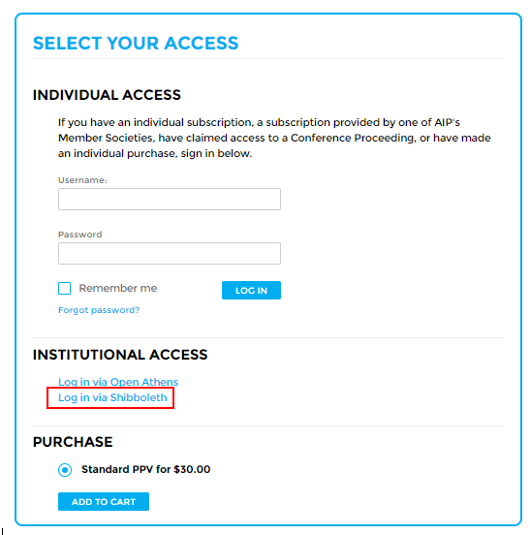

The user will be directed to a page that has the federations supported by Scitation.

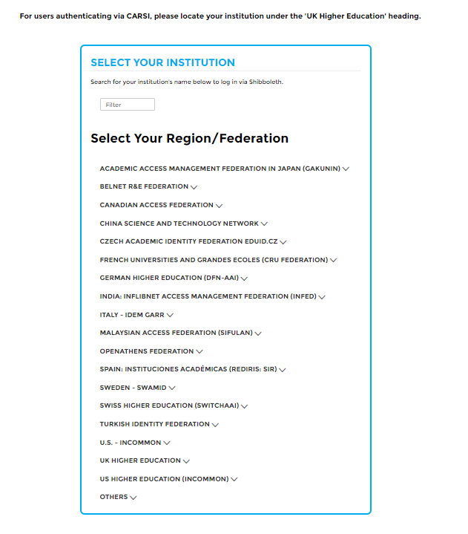

For a temporary period, institutions accessing via CARSI-CERNET will be listed under the ‘UK Higher Federation’ heading as noted on the Shibboleth page on Scitation. This will only be the case through the end of March 2020 – after March CARSI-CERNET will have a heading on the Shibboleth page.